ECO 101 Assignment Brief: Economics in Your Life
Due Date: August 24, 2025
Weight: 10% of Final Grade

Objective:
This assignment challenges you to apply the tools and concepts you've learned in ECO 101—opportunity cost, trade-offs, demand and supply, market equilibrium, consumer and producer surplus, taxation, price controls, cost structures, and market types—to a real-life situation that matters to you personally. YOU MUST USE AT LEAST 2 (TWO) CONCEPTS SIMULTANEOUSLY TO STUDY ONE INCIDENCE !!!
The best submissions will go beyond textbook examples and explore unexpected or novel areas where microeconomic reasoning helps reveal hidden mechanisms or insights.

Assignment Prompt:
Identify a real-life phenomenon, behavior, event, or decision that you personally encounter, observe, or are curious about. Then, use at least two major economic tools or concepts you’ve learned in this course to analyze and explain what’s happening beneath the surface.

Examples of Strong Topics vs Weak Topics:
Weak Topic | Why It’s Weak
Analyzing the price of rice in the market | Too generic; lacks novelty or personal connection
Why iPhones are expensive in Bangladesh | Overused, predictable
Strong Topic | Why It’s Strong
Why the local salon near my house offers heavy discounts on Wednesdays | Specific, local, shows understanding of marginal cost and price discrimination
The economics of marriage proposals in Dhaka (dowry, gifting, signals, opportunity costs) | Cultural, unexpected, multiple concepts involved
Analyzing traffic congestion through the lens of negative externalities and price ceilings on Uber fares | Real-world, layered, and timely

Your Assignment Must Include:
1. Title of your analysis
2. Introduction – What is the real-world subject you’re studying and why did you choose it?
3. Economic Analysis – Apply at least two major ECO 101 concepts. Include graphs, equations, or diagrams as needed.
4. Personal Insight – What did this teach you about economics or your own decision-making?
5. Creativity & Originality – This is a key criterion. Generic examples will not score well.
6. References – If you use data, cite your sources.

Assessment Rubric (out of 100):
Originality and Novelty of Topic | 25
Accurate and Insightful Economic Application | 25
Depth of Analysis (use of graphs, logic, and clarity) | 20
Personal Connection and Relevance | 15
Organization, Language, and Presentation | 10
References/Data Use | 5

A+ Model Example Submission

Title: “The Economics of Queue Jumping at Dhaka Street Food Stalls: A Study in Informal Monopoly Power and Price Discrimination”

Introduction:
Every evening near my university, I line up at a popular fuchka vendor on the footpath. Something always annoyed me: no matter how long I waited, someone always seemed to come in, nod to the seller, and get served almost immediately. At first, I chalked it up to favoritism. But over time, I noticed a pattern. These queue-jumpers weren’t necessarily friends of the vendor—they often handed over a larger bill without waiting for change, or ordered in bulk. This got me thinking: Is there an economic logic to this?
This analysis investigates how monopoly power, price discrimination, opportunity cost, and consumer surplus help explain queue-jumping behavior in informal street markets, and how vendors subtly respond to different consumer types to maximize profit — even in the absence of formal pricing.

Economic Analysis:

1. Market Structure: The Vendor as a Local Monopoly
While many fuchka stalls exist in Dhaka, in a given 100m radius, each vendor behaves like a local monopoly. Barriers to entry are low in theory, but consumer loyalty, location, and taste create effective monopoly-like market power within micro-territories. This means:
- The seller can influence service priority (like pricing in a monopoly).
- Consumers are price takers, but in non-monetary ways (i.e., waiting time becomes a currency).

2. Queue-Jumping as an Expression of Willingness to Pay
In a standard demand curve, price is the primary axis. But in time-based informal markets, waiting time substitutes for monetary price. Let's define:
- P = Effective price (including time cost)
- T = Time spent waiting, valued at a person's opportunity cost rate www
- M = Money paid
- w= subjective time cost
- Then total “price”; P = M + wT
A student whose time is worth w=20 BDT/min and who waits 10 minutes, is paying P=M+20(10) or P = M + 200. But a banker with w=100 BDT/min, jumping the queue and paying 50 BDT more than the student, incurs no time cost and pays P=(M+50)+0. So the vendor captures surplus from consumers with higher opportunity costs of time — classic third-degree price discrimination based on time elasticity of demand.

3. Consumer Surplus and Discrimination
Let’s define two types of buyers:
Type | Max Willingness to Pay (WTP) | Opportunity Cost of Time | Behavior
Students | 250 BDT | 20 BDT/min | Will wait 10 mins, pay 50 BDT
Professionals | 300 BDT | 100 BDT/min | Will pay 100 BDT to skip line
Vendor earns more from professionals, who have higher WTP and higher time value. By informally recognizing this (through cues like dress, speech, confidence), the vendor offers faster service only when it boosts their total revenue. This is a behavioral, non-price menu, and it works like price discrimination by type.

4. Graphical Representation
We can use a basic monopoly diagram:
- Downward-sloping demand curve D
- Marginal revenue curve MR
- Marginal cost MC is roughly flat since fuchka ingredients are cheap
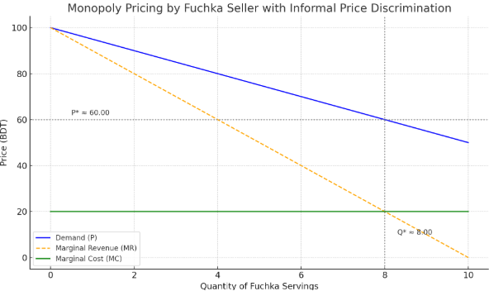
The vendor captures greater producer surplus by charging different effective prices (some through money, some through queue priority) rather than a single price. The shaded area between MRMRMR and MCMCMC up to the quantity sold indicates profit-maximizing behavior — just implemented through social cues and line behavior instead of posted pricing.

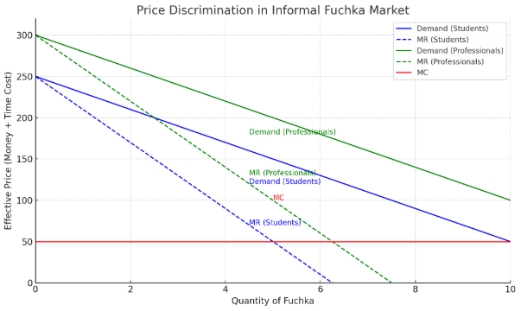
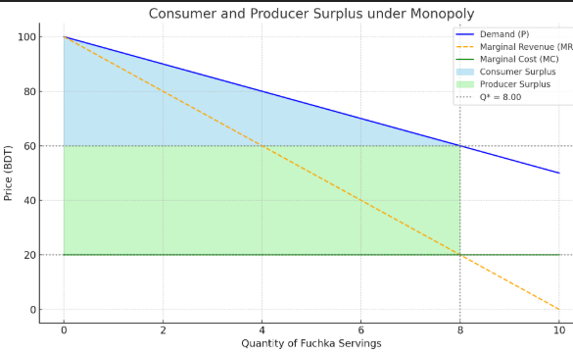
The vendor is maximizing profit by charging different effective prices:
- For students: they wait in line, so their cost is mainly time. Their monetary price is low.
- For professionals: they pay more money to avoid waiting, incurring low time cost.
In economic terms:
- The vendor picks the profit-maximizing quantity for each type where MR = MC.
- From the demand curve, this gives us two different prices:
  - Lower P for students (blue demand at MR=MC)
  - Higher P for professionals (green demand at MR=MC)
On the graph:
- Find the point where each MR curve crosses the MC line.
- Go up to the respective demand curve to find the price charged.
- The green group pays a higher price (less time + more money), while the blue group pays a lower price (more time + less money).
This is third-degree price discrimination:
- Based on observable characteristics (age, dress, behavior), the vendor estimates your type.
- You’re charged an implicit price (money or waiting time) that matches your group’s demand elasticity.
In other words:
- Professionals are less price-sensitive → charged more.
- Students are more price-sensitive → charged less but wait longer.
The graph shows how a fuchka vendor practicing monopoly pricing captures more surplus by recognizing two distinct consumer types. Professionals, with higher time value and willingness to pay, are served faster at higher prices. Students pay less but bear longer waits. This form of third-degree price discrimination maximizes vendor profit without explicit pricing, instead using line priority as a behavioral pricing tool.

5. Normative Implication: Is It Fair?
One might argue that queue-jumping is unfair, but economic efficiency says otherwise: those who value time more highly are served faster, and the vendor earns more. This is Pareto-improving if no one is made worse off — though perceptions of fairness differ.
It’s also a real-world market mechanism that compensates for the lack of formal pricing flexibility in informal economies. Where it breaks down is when consumers’ ability to pay is confused with entitlement, leading to social resentment or informal backlash (e.g., people scolding the vendor).

Conclusion and Personal Reflection:
Before this course, I saw the fuchka line as pure chaos or favoritism. Now, I see a rich microeconomic game with monopolistic behavior, informal price discrimination, and opportunity cost all playing out — all in a 2-meter stall with no visible pricing board.
Studying this made me realize that even “small” economic systems are full of complexity if we look closely. The invisible hand operates in subtle ways, often in the form of who gets served first and why.

What Makes This Submission A+:
- Technical Skill: Applies cost analysis, price discrimination theory, consumer surplus, opportunity cost, and monopoly logic rigorously
- Creativity: Applies formal economic models to an informal, culturally specific real-world context (Dhaka street vendor behavior)
- Synthesis: Uses both graphical and algebraic modeling intuitively
- Personal Insight: Shows transformed perception through economics
- Novelty: Not a textbook case — deeply original yet relatable

GOOD LUCK!!!

